Project Design Phase-II
Technology Stack (Architecture & Stack)

Date | 19 February 2026
Team ID | LTVIP2026TMIDS62122
Project Name | Startup Success Prediction System Using Machine Learning
Maximum Marks | 4 Marks

Technical Architecture:
The Deliverable shall include the architectural diagram as below and the information as per the table1 & table 2
Example: Order processing during pandemics for offline mode
Reference: https://developer.ibm.com/patterns/ai-powered-backend-system-for-order-processing-during-pandemics/
Guidelines:
Include all the processes (As an application logic / Technology Block)
Provide infrastructural demarcation (Local / Cloud)
Indicate external interfaces (third party API’s etc.)
Indicate Data Storage components / services
Indicate interface to machine learning models (if applicable)
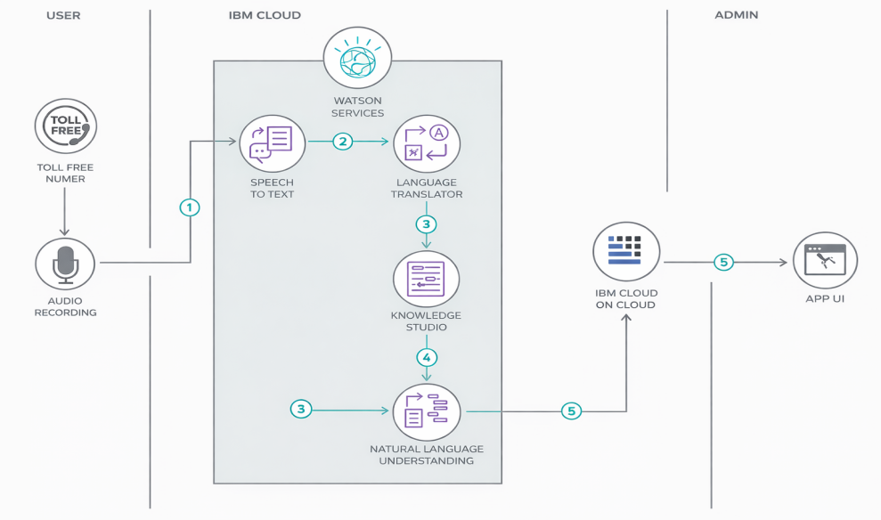

Table-1 : Components & Technologies:
S.No | Component | Description | Technology
1 | User Interface | How the user interacts with the application (Web UI, Mobile App, Chatbot, etc.) | HTML, CSS, JavaScript, Angular JS, React JS
2 | Application Logic – 1 | Core business logic handling application processes | Java / Python
3 | Application Logic – 2 | Speech processing logic | IBM Watson Speech to Text (STT) Service
4 | Application Logic – 3 | Conversational AI / Chatbot logic | IBM Watson Assistant
5 | Database | Stores structured data, configurations, and application records | MySQL, NoSQL
6 | Cloud Database | Managed cloud-based database service | IBM DB2, IBM Cloudant
7 | File Storage | Storage for uploaded files, documents, audio files, etc. | IBM Block Storage / Other Cloud Storage / Local Filesystem
8 | External API – 1 | Integration with third-party service | IBM Weather API
9 | External API – 2 | Government / Identity verification API integration | Aadhaar API
10 | Machine Learning Model | AI/ML model used in the system | Object Recognition Model
11 | Infrastructure (Server / Cloud) | Deployment environment of the application | Local Server / Cloud Foundry / Kubernetes

Table-2: Application Characteristics:
S.No | Characteristics | Description | Technology
1 | Open-Source Frameworks | List of open-source frameworks used in the application for development and deployment. | React JS / Angular JS (Frontend), Node.js / Python (Backend), Express.js, Spring Boot
2 | Security Implementations | Security mechanisms implemented including authentication, authorization, encryption, firewall protection, and vulnerability prevention. | SHA-256 Password Hashing, AES Encryption, HTTPS (SSL/TLS), JWT Authentication, OAuth 2.0, IAM Controls, OWASP Security Standards, Firewall
3 | Scalable Architecture | Architecture designed to handle increasing users and workload efficiently (e.g., 3-Tier or Microservices architecture). | Microservices Architecture, Docker Containers, Kubernetes, IBM Cloud Foundry
4 | Availability | Ensures system uptime and fault tolerance using redundancy and load balancing. | Load Balancer, Distributed Servers, IBM Cloud High Availability Setup
5 | Performance | Optimization techniques to handle high traffic and improve response time (e.g., caching, CDN, request handling). | Redis Cache, CDN (Cloudflare / IBM CDN), API Gateway, Asynchronous Processing

